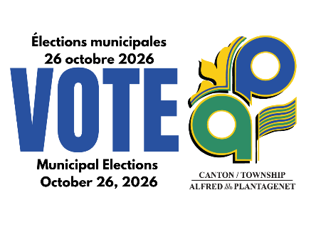 | FORM AP116e
CANDIDATE’S DECLARATION
PROPER USE OF VOTERS’ LIST

I,
being a candidate for the office of: _________________________________
in the 2026 elections, hereby request the clerk to provide me with the following information when it becomes available:
one paper copy of the Voters’ List
(available Tuesday, September 1, 2026) – please note that a copy of all revisions made to the Voters’ List will be provided on or before Wednesday, September 30, 2026.
an electronic copy of the Voters’ List via OneDrive
(available Tuesday, September 1, 2026) – please note that a copy of all revisions made to the Voters’ List will be provided on or before Wednesday, September 30, 2026.
a copy of the Lists showing the name of each person who has voted in accordance with the schedules established in Subsection 10 (4) of the Telephone/Internet Voting Election Policies and Procedures for the 2026 Municipal Elections.

I, the undersigned, do hereby agree to use the Voters’ List for the 2026 Municipal Election purposes only and I understand that I am prohibited by the Municipal Election Act, 1996 from using the Voters’ List for any other purposes.

I, the undersigned, do hereby commit to securely destroy any electronic or paper copy of the Voters’ List in my possession within 90 days of Election Day.

Signature |  | Date

