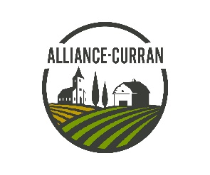

Family RALLY
July 10, 2021
Departure between 8:30 -- 9:30 am

Forum Communautaire
819 Cartier street, Curran

$10 / vehicle
Having fun with family,
Visit the countryside,
Discover the farms,
Locate merchants and
Historical sites in
Curran and Pendleton
Learn about our history.

Rally ends at Curran Park
791 Mill Street, Curran

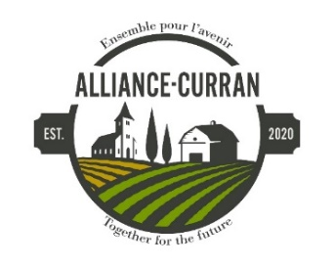
Don`t forget your camera.

Picnic at Curran Park
Hot dogs, beverages and more
Canteen on site

Get a chance to WIN
50% of the entries will be given in
3 participations prizes

Please send your registration
before July 3rd, 2021

by e-mail:
Alliancecurran20@gmail.com

Or by fax
613-673-4086

Or by mail
Box 40, Plantagenet, ON

Or contact
Louise Sauvé at 613-852-4789

The Rally is organized according to the standards of the
Eastern Ontario Health Unit.
Certain restrictions apply to protect all participants for COVID-19 pandemic.

You will receive the rules at the start of the rally.

Family RALLY – Registration form
Saturday, July 10, 2021
Cost: 10.00$ par vehicle
Driver’s name
Address
Email
Passengers’ names Age

Responsable Signature
Have a nice day!
Enjoy and be safe!
Please give us your comments and suggestions
at the end of the rally. THANK YOU!

